Integrating Technology for Intelligent Products, Systems and Services
The vision for this module is that Industrial Design will be about Intelligent Products which are Adaptive with respect to the user and to the environment. Moreover Industrial Design will not only be concerned with products but more and more with Systems and Services. This is because the products are connected, for example via the Internet and via wireless connections and because the users are connected through their social context. One of the most important tasks for designers is to explore what things mean to humans. The explorations, coupled to constructive activities, will lead to innovative Products, Systems and Services. Adaptive systems have sensors, computation and actuators. Whereas for traditional Industrial Design products it would be enough to create drawings and CAD models, for Intelligent Products, Systems and Services it is much better to create experiential prototypes as well.
The relationship between sensors, actuators, computation, individual users, users in a societal context, sustainability, the internet, the health care system, and the business aspects, is sketched in the figure below.
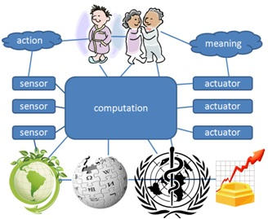
Learning objectives
In this course the students will learn how to make explorative experiential prototypes with simple sensors, actuators and computation. A key role will be played by the Arduino, an embedded computation platform which facilitates easy prototyping of simple systems with sensors and actuators. This will be the vehicle for the practical assignments. The competency of Integrating Technology for Intelligent Products, Systems and Services is not just a specific type of knowledge, but includes a certain attitude and a set of skills. The knowledge includes elements of electronics and computer science. The skills include bread-boarding, Arduino programming, cardboard modeling and 4D sketching. The attitude includes exploration, experiential prototyping and discussion.
Learning activities
The learning takes place mostly through the student's own constructive activities in which experiential prototypes of increasing difficulty are created and explored. Specific lectures are possible. Group presentations and discussions are essential.

Specific assignments could be:
- learn to design an electronic circuit with an op-amp;
- learn how to use op-amps for reading sensors;
- learn how to measure temperature with an Arduino;
- learn how a servo motor works;
- learn examples of product semantics and affordances;
- learn how to control LEDs and DC motors with transistors;
- learn how to use transistors in combination with Arduino;
- learn how to express an emotion through a movement;
- learn how to measure heart rate variability.
In each case the prototype must be embedded in a user context and the meaning of the design result must be explored experientially.

